EGC Speakers 2026 – 2027

Nancy Mandel
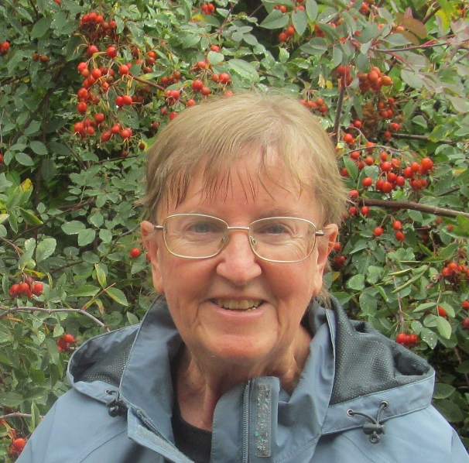

Nancy Mandel and her husband David bought their first house in 1978 and shortly thereafter she bought her first rosebush. She has been growing roses ever since, nearly 50 years. She was a member of the Corvallis Rose Society until its demise, serving as its president for a year and running the Corvallis Rose Show for seven years. She will be presenting an Introduction to the World of Roses, covering lots of rose topics (science, classifications, cultivation, books, etc.)

Cindy Funes

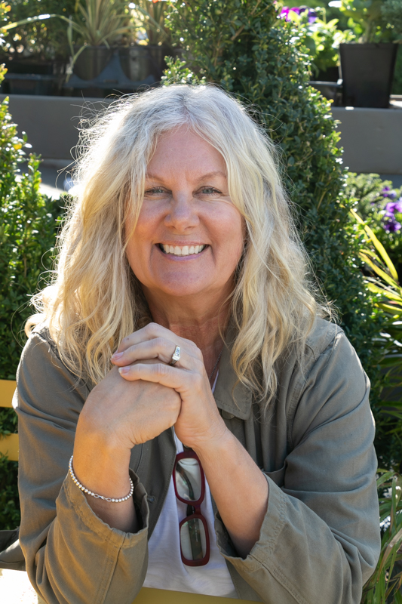

Cindy Funes is a Certified Professional Horticulturist and founder of Garden Revelry, with years of experience designing and caring for client’s container gardens throughout the Pacific Northwest. In Contained Brilliance: Container Garden Like a Pro, Cindy draws on that hands-on experience to share practical design tips, inspiring plant combinations, and professional tricks to help gardeners create containers that feel balanced, beautiful, and personal. Her warm, conversational style offers a behind-the-scenes look at how the pros approach container gardening, with ideas that are approachable, beautiful and easy to put into practice at home.

Signe Danler
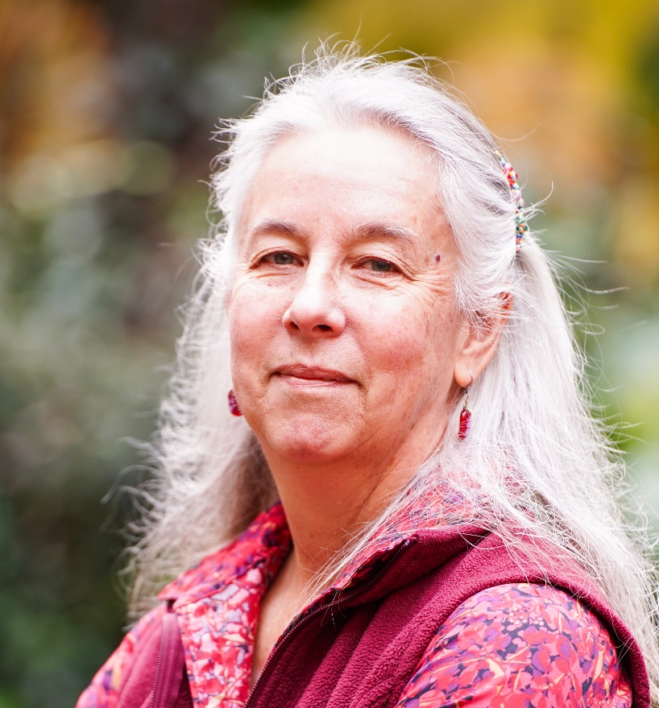

Signe Danler is a veteran Master Gardener and landscape designer. Her Horticulture degrees from OSU include a Soil Science minor and special study of Environmental Science and Urban Forestry. For ten years she has been the instructor for the OSU online Home Horticulture class, and provided online materials for the Master Gardener Program. She also works with Gail Langellotto’s Garden Ecology Lab, and develops research-based Integrated Pest Management (IPM) material for the SolvePestProblems website, both based at OSU.
Signe is also a member of the Willamette Valley Regenerative Landscape Coalition, which explores and promotes regenerative landscape practices. Both personally and professionally, she enjoys educating people in how to apply ecological and restorative principles to landscape design and management.
She has been a member of the Evening Garden Club practically forever.

Don Boucher
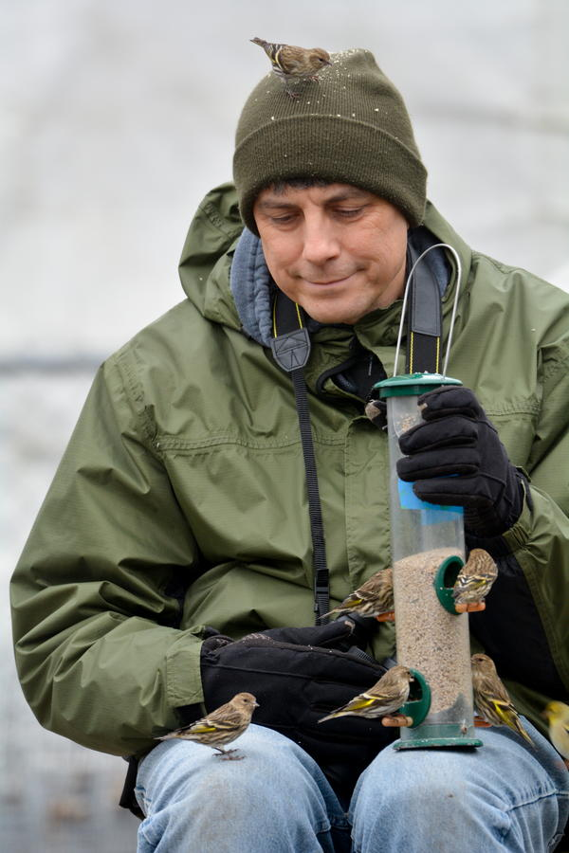

Don Boucher is an amateur Naturalist who lives in Corvallis. He and
Lisa Millbank run the Neighborhood Naturalist program. They offer hikes
and resource links to promote interest about nature in mid-Willamette
Valley backyards, neighborhoods, and countryside.

Janet Magedanz

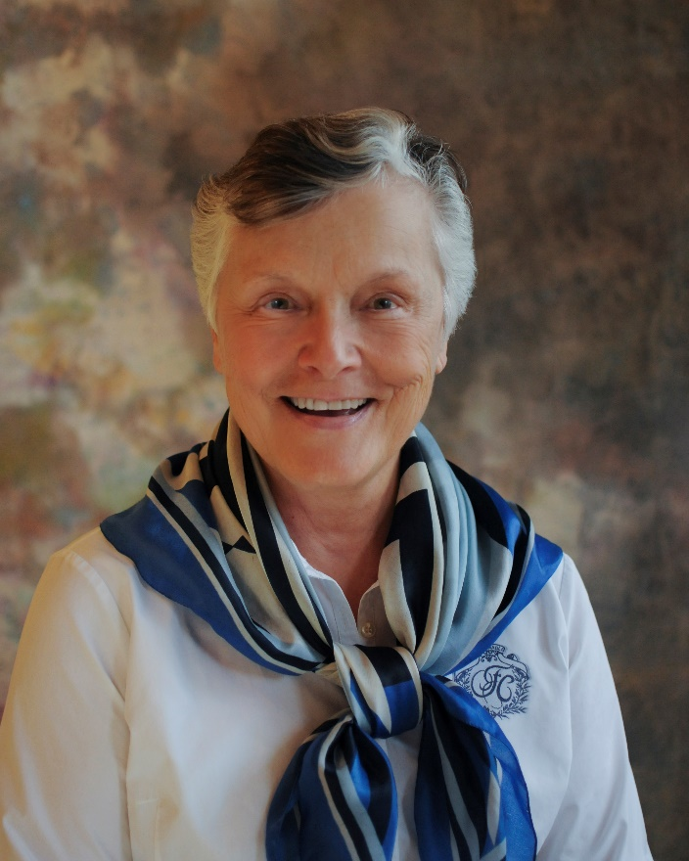

Janet Magedanz has been gardening on her 1 acre property for nearly 50 years and has learned a lot about what works and what doesn't. She has discovered that many of the bits of garden wisdom aren't! Her presentation entitled "Garden Myths' will be both entertaining AND instructive.

